DIGITAL MARKETING

PROJECT

*Competitor Analysis Report: Jio vs. Airtel & Vodafone/Vi*

|  |
| --- |
| Index |
| |  |  | | --- | --- | | SR.NO | TOPICS | | 1 | OBJECTIVES | | 2 | ACTIVITY | | 3 | SUMMERY | |

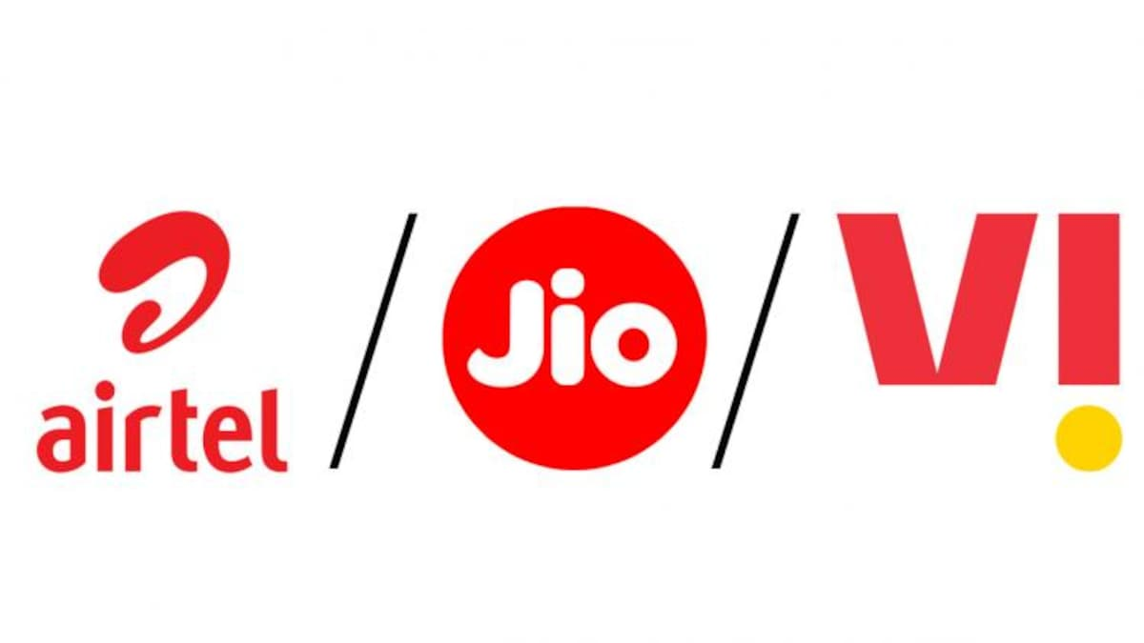

*1: Objectives-*

The primary objective of this analysis is to understand how Jio compares with its top competitors. The analysis focuses on digital marketing strategies, including website performance, social media presence, and online advertising

*2: Activity-*

1. Overview of Competitors

Jio: A major player in the Indian telecommunications market, known for its competitive pricing , and strong push for digital services.

Airtel: Another major telecom provider in India with a broad customer base, strong network infrastructure, and a diversified portfolio, digital TV, and mobile services.

Vodafone: Now operating as Vi (Vodafone Idea) after the merger with Idea Cellular, Vodafone is another significant telecom brand in India, known for its strong customer service and international presence.

2. Website Performance

Jio

- Design & User Experience: Clean and modern with a focus on digital services.

- Content: Jio's website is rich in content, with a focus on promotions, and digital services like JioSaavn and JioTV.

- SEO Performance: Strong SEO strategy with high search engine rankings for various relevant keywords.

Airtel

- Design & User Experience**: Professional and business-like, with clear categorization of services.

- Content: Airtel’s website is well-structured, with an emphasis on customer service and product offerings like Xstream and Wynk Music.

-SEO Performance: Competitive SEO with good keyword coverage, though slightly behind Jio in terms of ranking for specific telecom-related searches.

Vodafone

- Design & User Experience**: User-friendly but less visually appealing than Jio and Airtel. Focuses on practical information.

- Content : The site has adequate content but lacks the depth seen in Jio and Airtel’s offerings. The focus is on plans and customer support.

- SEO Performance: Decent SEO strategy, though not as strong as Jio’s or Airtel’s. Struggles with visibility on some critical keywords.

3. Social Media Presence

Jio

- Platforms: Active on Facebook, Instagram, Twitter, and YouTube.

- Engagements: High engagement rate across platforms, particularly on Twitter, where Jio frequently addresses customer queries.

-Content Strategy : Focus on promotional content, customer engagement, and updates about digital services. Utilizes a mix of video content, infographics, and customer testimonials.

Airtel

- Platforms: Strong presence on Facebook, Instagram, Twitter, and LinkedIn.

- Engagement: Consistent engagement, especially on LinkedIn, where Airtel targets a professional audience.

-Content Strategy: Airtel’s content is more business-oriented, focusing on corporate achievements, CSR activities, and customer success stories.

Vodafone

- Platform’s : Active on Facebook, Twitter, Instagram, and YouTube.

- Engagements: Moderate engagement, with Twitter being the most active platform.

- Content Strategy’s : The content revolves around customer service, with a significant emphasis on addressing complaints and providing solutions.

4. Online Advertising Efforts

Jio

- PPC Campaigns: Aggressive PPC campaigns targeting a wide range of keywords related to telecom services, and smartphones.

- Display Ads: Extensive use of display ads, particularly on tech-related websites and news portals.

Airtel

- PPC Campaigns: Effective but less aggressive than Jio. Focus on specific high-value keywords like “broadband plans” and “Airtel Xstream.”

- Display Ads: Utilizes display advertising to target both consumer and business segments, particularly on professional networks like LinkedIn.

Vodafone

- PPC Campaign’s : Limited PPC presence compared to Jio and Airtel. Focuses on brand-specific keywords rather than a broader range.

- Display Ads : Minimal display advertising, with a focus on retargeting existing customers.

5. Key Takeaways

- Jio leads the competition with a robust digital marketing strategy, particularly in SEO, social media engagement, and video advertising. Its aggressive approach has helped establish a strong digital presence.

- Airtel maintains a competitive edge with a more professional and business-oriented strategy, excelling in LinkedIn and targeted advertising.

-Vodafone lags behind both Jio and Airtel in terms of digital presence and advertising efforts, focusing more on customer service than aggressive digital marketing.

*3: SUMMARY*-

The Indian telecom market is highly competitive, with Jio, Airtel, and Vi constantly vying for market share. Jio’s entry transformed the market, leading to consolidation and price wars. The competition primarily revolves around pricing, network quality, data offerings, and additional services like digital content and financial services. The push towards 5G is the next major battleground for these players. This analysis highlights how each competitor approaches the digital space and provides insights into potential areas for improvement.